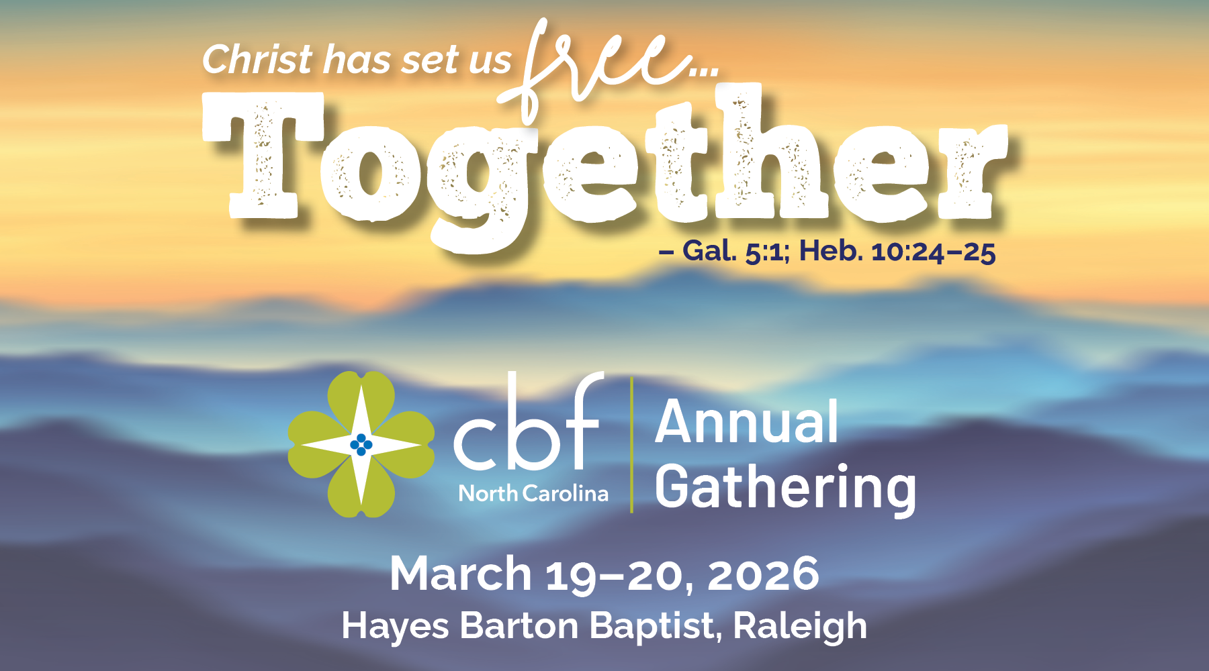
Sample Newsletter/E-Newsletter/Bulletin Promotional Text
The Cooperative Baptist Fellowship of North Carolina’s 2026 Annual Gathering is coming up soon, March 19–20 at Hayes Barton Baptist Church in Raleigh. Come experience the joy of connection and belonging as we worship, learn, share stories and celebrate together about how God is at work in our churches and communities across the state. You are welcome to participate for the entire two days or for only the sessions that fit your schedule. Get more info & register online by March 4 at cbfnc.org/annualgathering.

Everyone in our church is invited to the 2026 Cooperative Baptist Fellowship of North Carolina Annual Gathering, March 19–20 at Hayes Barton Baptist in Raleigh. Based on Galatians 5:1 and Hebrews 10:25, this year’s theme is “Free Together.” Whether you go every year, haven’t been in a while or have never been, come and see what it’s all about. Find more info at cbfnc.org/annualgathering.

Sample Social Media Posts
Have you registered yet for CBF North Carolina’s 2026 Annual Gathering, March 19–20 in Raleigh? Come be inspired and challenged by great speakers, worship God together and connect with other like-minded Baptists from across our state! Register today at cbfnc.org/annualgathering.

Come to our yearly Cooperative Baptist family reunion at the CBF of North Carolina Annual Gathering in Raleigh, March 19–20. Get details & register online by March 4: cbfnc.org/annualgathering.

We hope to see you at Hayes Barton Baptist Church in Raleigh March 19–20 for the CBFNC Annual Gathering, “Free Together.” Be sure to register by March 4 at cbfnc.org/annualgathering.

Wondering what the CBFNC Annual Gathering is all about? Come see for yourself, March 19–20 at Hayes Barton Baptist, Raleigh. Learn something new from current theologians, church leaders & ministry partners in the variety of workshops offered. Get more info & register at cbfnc.org/annualgathering.

CBFNC Annual Gathering 2026—it’s not just for clergy! It’s for everyone who loves their church, values community or is simply curious about CBFNC. Come bring a friend, meet new people and come discover how your unique gifts and faith journey fit into something bigger. March 19–20 at Hayes Barton Baptist, Raleigh. Get more info & register at cbfnc.org/annualgathering.

